The data below is from this year’s calibration of GPI measurement, the units of r and z are mm. The resolution we used is 1860*800, I attached a picture below.

|  |  |  |  |  |  |
| --- | --- | --- | --- | --- | --- |
|  |  | **RADIUS** | **Z** | **PIX** | |
| **Description** | **site** | **Measured** | **Measured** | X | Y |
| Outer box corners | up outer | 1357.295 | 258.050 | 342 | -482 |
| Outer box corners | up inner | 1556.120 | 287.010 | 670 | -489 |
| Outer box corners | down inner | 1599.654 | 133.330 | 664 | -823 |
| Outer box corners | down outer | 1402.290 | 102.463 | 331 | -823 |
| Inner box corners | up outer | 1416.591 | 225.684 | 422 | -569 |
| Inner box corners | up inner | 1518.442 | 242.289 | 591 | -575 |
| Inner box corners | down inner | 1539.795 | 165.376 | 587 | -738 |
| Inner box corners | down outer | 1438.989 | 149.477 | 418 | -738 |
| center | center | 1476.312 | 195.060 | 509 | -656 |

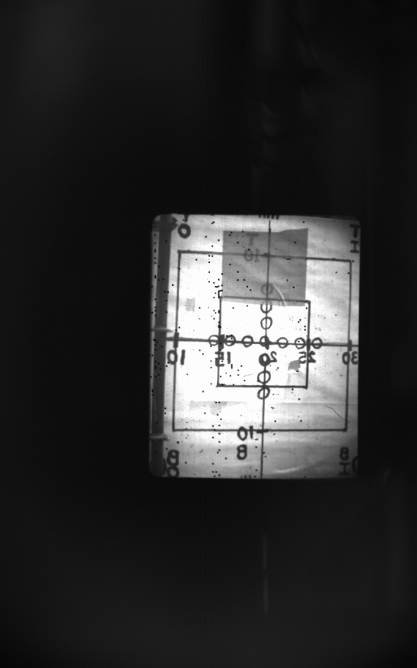

I think there is a linear relationship between the real site coordinate system and the pix coordinate system. They satisfy the equations below:



Then I used all the data to fit the equations



I used the equations to calculate the GPI camera observation area, it is different from you got last year.

|  |  |  |  |
| --- | --- | --- | --- |
|  | 2010 /cm | 2011 /cm |  |
| R1 | 140.3 | 138.7 | -1.6 |
| Z1 | 7.05 | 6.2 | -0.85 |
| R2 | 163.7 | 162.4 | -1.3 |
| Z2 | 8.19 | 9.6 | 1.41 |
| R3 | 134.1 | 133 | -1.1 |
| Z3 | 31.3 | 28.9 | -2.4 |
| R4 | 157.6 | 155.4 | -2.2 |
| Z4 | 32.4 | 32.4 | 0 |

But I compared the pictures for the two calibration, they are same. I don’t know why.

The picture below is I put the pictures for the two calibration together by using photoshop, I set last year’s picture as background and this year’s as the second layer. The transparency of the second layer is 90%. They matched very well.

