Record of Discussion for FY2012 NSTX Research Collaboration Proposals

Key results of discussions between prospective NSTX collaborators and an NSTX Research Contact
in support of University and Industry Diagnostic Collaboration proposals submitted to DOE.

A completed and signed record of discussion must be included with collaboration proposals to DOE which are due Tuesday, October 18, 2011, 11:59 PM Eastern Time.

Please send completed and signed forms (preferably with scanned or digital signature included in this MS Word document) to Jon Menard (jmenard@pppl.gov) and Masa Ono (mono@pppl.gov) no later than Tuesday, October 11, 2011, 5PM EST for final review and comment.

Questions or comments regarding processing of this form should be forwarded to Thomas Egebo (tegebo@pppl.gov). The NSTX Project Fax Number is (609) 243-2222.

Title of Research Activities:  Enhanced Gas Puff Imaging Diagnostic for 3-D Edge Turbulence Studies |  |  |  | Collaboration began (mm/yy) or New:  New
Off-Site Institution:  University of Colorado |  |  | Discussion Dates  Initiated on: July 1, 2011  Completed on: October 10, 2011
Collaboration Principal Researcher:  Name: Tobin Munsat  Email: tobin.munsat@colorado.edu  Tel: (303) 735-5596  Signature: 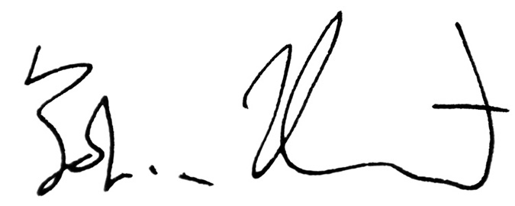  Date: 10/10/11 | On-Site Research Contact:  Name: Stewart Zweben  Email: szweben@pppl.gov  Tel: (609) 243-3243  Signature:  Date:
Research Goals:
Design and install an upgraded Gas Puff Imaging diagnostic on NSTX. This would include the following six views:
- Bay B, just above outer midplane (i.e. existing GPI view)
- Bay B, symmetrically just below outer midplane. This view will use the same window/mirror port as view 1, but will look the opposite direction along the same flux tube.
- Additional view below outer midplane, illuminating a poloidally-distinct flux tube from views 1 and 2. Two views of the first three should be toroidally spaced to sample opposite phases of the RMP coil set if possible.
- Inner wall view (can use a nearly radial viewport with an inner-wall gas manifold).
- Divertor X-point view.
- Lower divertor view from top of vessel. Both views 5 and 6 correspond to existing viewports on NSTX, and there is an existing gas manifold in the NSTX divertor.

Off-Site Research Tasks:
Design of complete system, project management and coordination. Design of experiments and analysis of data.

On-Site Research Support Tasks:
The proposal includes a postdoc to be located at PPPL for this project. The postdoc would handle most of the hands-on construction and installation, working with the NSTX team (including S. Zweben, B. Stratton, R. Kaita, L. Roquemore, etc.).

Estimated Researcher Effort Required (Man-Months): ~1 from the PPPL team, in addition to the full-time effort of the postdoc.
On-Site Engineering Support Tasks:
- Design and fabrication of re-entrant viewports and integration into larger NSTX diagnostic ports
- Design and fabrication of in-vessel gas-puff manifolds, and integration into NSTX gas handling system.

Engineering Effort Required (Man-Months): ???
Estimated Hardware Cost Required ($k): ???
Collaboration Researcher Questions and Issues:
1) What diagnostic ports are potentially (realistically) available for GPI views?
2) How do these match with existing and/or possible future in-vessel gas manifolds?
3) The bottom-line question is whether the six views listed in the “research goals” section are realistically achievable on NSTX.
4) How much engineering design work and hardware costs should be budgeted for the NSTX vessel interfaces (viewports and gas manifolds)?

Responses by On-Site Research Contact and Task Manager:
1)

2)

etc.
Additional Collaboration Researcher’s Comments (if any):
1)

2)

etc.
Additional On-Site Research Contact and Task Manager Comments (if any):
1)

2)

etc.
Review and Comment:  NSTX Program Director  Signature  October ??, 2011  Date |  | Review and Comment:  NSTX Project Director, Concurrence  Signature  October ??, 2011  Date

