Princeton Plasma Physics Laboratory
NSTX-U Experimental Proposal
Title: Relationship Between Plasma Turbulence and SOL Width Scaling in NSTX-U
OP-XP-1514 | Revision: 1 | Effective Date:  (Approval date unless otherwise stipulated)  Expiration Date:  (2 yrs. unless otherwise stipulated)
PROPOSAL APPROVALS
Responsible Author: TK Gray |  |  | Date
SG, TSG or TF Leader (assigned by RC): V Soukhanovskii |  |  | Date
Run Coordinator (RC): J Menard |  |  | Date
Responsible Division: Experimental Research Operations
RESTRICTIONS or MINOR MODIFICATIONS
(Approved by Experimental Research Operations)

NSTX- EXPERIMENTAL PROPOSAL
TITLE: Relationship Between Plasma Turbulence and SOL Width Scaling in NSTX-U | No. OP-XP-1514
AUTHORS: TK Gray, S Zweben | DATE:

1. Overview of planned experiment
The goal in this experiment is to measure the variations in the SOL width observed under various NSTX-U parameters and correlate that with measurements of SOL turbulence at the midplane and in the divertor as a function of P_{NBI}, I_{p}/B_{t} and varying amounts of pre-discharge Li deposition.

2. Theoretical/ empirical justification
The use of lithium wall conditioning in NSTX resulted in a reduction of SOL width, λ_{q} as measured by divertor infrared (IR) cameras. Modeling performed by the Lodestar group suggests this contraction is due to reduced interchange turbulence, which is brought about because of the reduced pedestal density gradient that occurs with the addition of lithium. Modeling with the XGC1 code predicts strong neoclassical effects are responsible for the contraction of λ_{q}. This experiment seeks to measure midplane SOL turbulence as measured by Gas Puff Imaging (GPI), Beam Emission Spectroscopy (BES) and Reflectometry and compare those data with Langmuir probe, visible imaging (tangential and perpendicular views), and IR thermography measurements in the lower divertor at several combinations of I_{p}/B_{t}, injected beam powers and Li depositions.

3. Experimental run plan
This proposal is separated into two parts. Part 1 uses minimal Li wall conditioning with evaporation rates between 10 – 50 mg of Li depending on what’s required for the discharge to run successfully. The second part of the proposal repeats the first part but substantially increases the amount of pre-discharge Li evaporation to ~ 300 mg. The actual amount of Li evaporation used will depend on the machine conditions on the day of experiment. Table 1 summarizes the proposed shot plan.

It’s preferred to utilize all available NBI #1 sources prior to using sources from NBI #2. When sources from the second NBI line are used, short (~20ms) pulses of source 1B are synchronized every ~100ms with notches of the second NBI sources to obtain time evolution of ion temperature, toroidal rotation and Zeff from CHERS measurements. The optimum setup for NB blips/notches will be determined after the “CHERS assessment” XMP.
Part 1 – Minimal Li Evaporation (8 shots total)
- Establish H-mode fiducial discharge shape with the following conditions (1 shot):
  - I_{p} = 0.9 MA, B_{T} = 0.45 T, P_{NBI} = 4 MW and outer strike point placed on the row 2 tile of the outboard divertor (r ~ 0.65 m)
- Repeat this step 1 for reproducibility (1 shot).
- Increase beam power to 8 MW with low Li evaporation and take 2 shots at these conditions (2 shots)
  - I_{p} = 0.9 MA, B_{T} = 0.45 T, P_{NBI} = 8 MW
- Increase I_{p} and B_{t} to 1.3 MA and 0.65 T with P_{NBI} = 4 MW (2 shots)
  - If machine conditions and administrative limits allow, operate at I_{p} = 1.5 MA and B_{T} = 0.75 T
- Keep I_{p} = 1.3 MA(1.5 MA) and B_{t} = 0.65 T (0.75 T), increase beam power to 8 MW with low Li evaporation and take 2 shots at these conditions (2 shots)
Part 2 – High Li Evaporation (8 shots total)
- Repeats steps 1 – 5 with a large amount (~ 300 mg) of Li evaporation
  - See Table 1 for prioritization of shots in part 2
  - Allow 2 – 4 shots to adjust centerstack fueling when the Li evaporation is first increased. Look to the fueling that was required for discharges in XP 1529 with similar Li deposition amounts as a guide.
Table 1 describes the matrix of desired shots, listed in priority order, for this proposal with 4 shots left as contingency to adjust center stack fueling and to achieve the highest power discharges when greater amounts of Li evaporation is begun.

Table 1: Proposed Shot Matrix listed in priority order and diagnostic check-list. Diagnostics not listed below, that are listed as ‘Needed’ Diagnostic Checklist, are to be run every shot. Contingency scenarios for the diagnostics listed below are given in Section 4.
Minimal Li
Shot | Ip [MA] | Bt [T] | P_{NBI} (MW) | GPI | SOL Refl. | Probes
1 | 0.9 | 0.45 | 4 | Early | Swept | Swept
2 | 0.9 | 0.45 | 4 | Late | Fixed Freq. | i_{sat}
3 | 0.9 | 0.45 | 8 | Early | Swept | Swept
4 | 0.9 | 0.45 | 8 | Late | Fixed Freq. | i_{sat}
5 | 1.3/1.5 | 0.65/0.75 | 4 | Early | Swept | Swept
6 | 1.3/1.5 | 0.65/0.75 | 4 | Late | Fixed Freq. | i_{sat}
7 | 1.3/1.5 | 0.65/0.75 | 8 | Early | Swept | Swept
8 | 1.3/1.5 | 0.65/0.75 | 8 | Late | Fixed Freq. | i_{sat}
Heavy Li
9 | 0.9 | 0.45 | 4 | Early | Swept | Swept
10 | 0.9 | 0.45 | 4 | Late | Fixed Freq. | i_{sat}
11 | 1.3/1.5 | 0.65/0.75 | 4 | Early | Swept | Swept
12 | 1.3/1.5 | 0.65/0.75 | 4 | Late | Fixed Freq. | i_{sat}
13 | 0.9 | 0.45 | 8 | Early | Swept | Swept
14 | 0.9 | 0.45 | 8 | Late | Fixed Freq. | i_{sat}
15 | 1.3/1.5 | 0.65/0.75 | 8 | Early | Swept | Swept
16 | 1.3/1.5 | 0.65/0.75 | 8 | Late | Fixed Freq. | i_{sat}

4. Required machine, NBI, RF, CHI and diagnostic capabilities
Needed XMPs: CHERS Assessment, Commission ISOFLUX and rtEFIT
Needed XPs: “Controlled introduction of Lithium into NSTX-U” (1529)
Desired, but not necessary XPs: “Investigating small-scale edge turbulence with GPI”

GPI requires a ratio of I_{p} (MA) / B_{T} (T) = 2 for optimal viewing. Table 2 is a list of viable I_{p} and B_{T} combinations in NSTX-U to optimize the GPI view. The XP titled “Investigating small-scale edge turbulence with GPI” will seek to optimize view in NSTX-U. During operation of NSTX, GPI was typically operated with I_{p} = 0.9 MA and B_{T} = 0.45 T. While this is still an option in NSTX-U, machine and administrative conditions allowing, I_{p} and B_{t} may be increased up to 1.5 MA and 0.75 T respectively.

Diagnostics
- Given improvements in GPI collection optics for NSTX-U, it may be possible to run GPI with much less gas than was used in NSTX.
I_{p} (MA) | B_{T} (T)
0.9 | 0.45
1.1 | 0.55
1.3 | 0.65
1.5 | 0.75
Table 2: Viable I_{p} and B_{T} for optimal GPI view.
  - If this is the case, and the reduced gas puff from GPI doesn’t interfere with CHERS measurements, GPI should be run every shot rather than altering as listed in Table 1.
  - If this is not the case, GPI should be alternated between times ‘early’ and ‘late’ in the shot. Delaying GPI until later in the shot will allow CHERS and BES measurements to get measurements ‘early’ in the shot.
    - Early ~ 500 ms
    - Late ~ 800 ms
    - Each GPI gas puff lasts for ~ 200 ms
  - The exact timing of the GPI puffs will be determined at the time of the XP
- SOL reflectometer will run either in fixed or swept frequency on alternating shots.
- Divertor Langmuir probes will alternate between fixed bias voltage (i_{sat}) for turbulence measurements or swept bias for divertor n_{e} and T_{e}
  - It may be possible to run ½ the probes in fixed bias and ½ with swept bias depending on availability of a 2nd bias power supply for the probes. If this is the case, run the probes in this manner instead.

5. Planned analysis
EFIT, SOLT, XGC1 and SOLPS

6. Planned publication of results
Results allowing, this will be published at the next PSI and IAEA meetings.

7. Estimated Neutron Production
Based on the number of shots, plasma current levels, and expected durations, estimate the maximum neutron production of this experiment. See calculator in Appendix #2 for this calculation.
# of Shots used in Estimate: 20 Estimated Total Neutron Production: 2.2E16

PHYSICS OPERATIONS REQUEST
TITLE: Relationship Between Plasma Turbulence and SOL Width Scaling in NSTX-U | No. OP-XP-1514
AUTHORS: TK Gray, S Zweben | DATE:

Brief description of the most important operational plasma conditions required and any special hardware requirement: The exact elongation and triangularity of the reference shot are not critical. More important, the shot should be an H-mode shot capable of running at [Ip,Bt] combinations as high as [1.3,0.65], or potentially [1.5,0.75], with up to 8 MW of power. The OSP shall be kept at 65 cm
Previous shot(s) which can be repeated:
Previous shot(s) which can be modified:
Machine conditions (specify ranges as appropriate, strike out inapplicable cases)
B_{T} Range (T): 0.45 – 0.65/0.75 Flattop Duration (s): 1 sec or greater
I_{P} Range (MA): 0.9 – 1.3/1.5 Flattop Duration (s): 1 sec or greater
Configuration: LSN, drsep <= -10 mm
Equilibrium Control: Isoflux (rtEFIT) with Strike-point control (rtEFIT)
Outer gap (m): 10 cm Inner gap (m): Z position (m):
Elongation: see above Triangularity (U/L): see above OSP radius (m): ~ 0.65 m
Gas Species: D Injector(s):
NBI Species: D Heating Duration (s):
Voltage (kV) 50 cm (1C): 90 60 cm (1B): 90 70 cm (1A): 90
Voltage (kV) 110 cm (2C): 90 120 cm (2B): 90 130 cm (2A): 90
ICRF Power (MW): 0 Phase between straps (°): Duration (s):
CHI: Off Bank capacitance (mF):
LITERs: On Total deposition rate (mg/min) or dose per discharge (mg): Varies. See run plan for Li deposition amounts for each discharge.
EFC coils: On

DIAGNOSTIC CHECKLIST [1]
TITLE: Relationship Between Plasma Turbulence and SOL Width Scaling in NSTX-U | No. OP-XP-1514
AUTHORS: TK Gray, S Zweben | DATE:

Note special diagnostic requirements in Sec. 4
Diagnostic | Need | Want
Beam Emission Spectroscopy |  | ✓
Bolometer – midplane array
CHERS – poloidal |  | ✓
CHERS – toroidal | ✓
Divertor Bolometer (LADA) |  | ✓
Divertor visible cameras | ✓
Dust detector
Edge deposition monitors [2]
Edge neutral density diag. |  | ✓
Edge MIGs [2] |  | ✓
Penning Gauges [2] |  | ✓
Edge rotation diagnostic |  | ✓
Fast cameras – divertor [2] | ✓
Fast ion D_alpha - poloidal
Fast ion D_alpha - toroidal
Fast lost ion probes - IFLIP
Fast lost ion probes - SFLIP
Filterscopes [2] |  | ✓
FIReTIP
Gas puff imaging – divertor
Gas puff imaging – midplane | ✓
Hα cameras - 1D [2] | ✓
Infrared cameras [2] | ✓
Langmuir probes – divertor |  | ✓
Langmuir probes – RF
Langmuir probes – RF ant. |  | ✓
Magnetics – Diamagnetism |  | ✓
Magnetics – Halo currents
Magnetics – RWM sensors

Note special diagnostic requirements in Sec. 4
Diagnostic | Need | Want
MAPP
Mirnov coils – high f.
Mirnov coils – toroidal array
MSE-CIF
MSE-LIF
Neutron detectors [2] | ✓
Plasma TV
Reflectometer – 65GHz
Reflectometer – correlation
Reflectometer – FM/CW
Reflectometer – fixed f |  | ✓
Reflectometer – SOL |  | ✓
SSNPA [2]
RF edge probes
Spectrometer – divertor |  | ✓
Spectrometer – MonaLisa |  | ✓
Spectrometer – VIPS |  | ✓
Spectrometer – LOWEUS |  | ✓
Spectrometer – XEUS |  | ✓
TAE Antenna
Thomson scattering | ✓
USXR – pol. Arrays |  | ✓
USXR – multi-energy
USXR – TG spectr.
Visible Brems. det. [2] |  | ✓

Notes:

[1] Check marks in this table do not guarantee diagnostic availability. Check with diagnostic physicists or research operations management to ensure diagnostic coverage.

[2] In some cases, a given line represents multiple diagnostics. For instance, there are multiple SSNPAs, multiple IR cameras, multiple neutron detectors, and multiple Langmuir probe arrays.

Appendix #1: Allowed Neutral Beam Power vs. Pulse Duration

Heating of the primary energy ion dump limits the beam duration to that given in the following table:
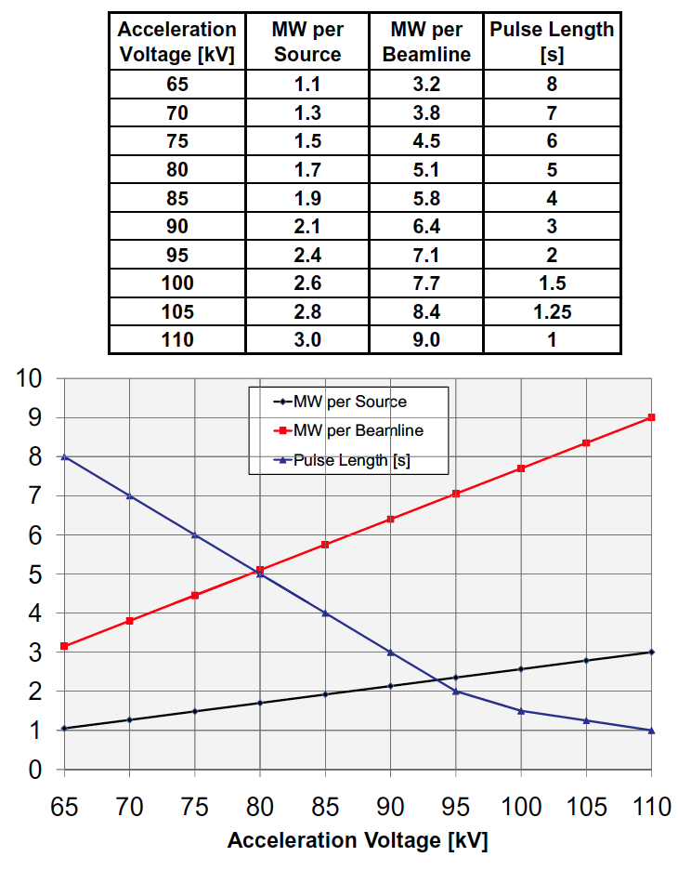
Table A1: Beam power and pulse length as a function of acceleration voltage

Appendix #2: Table for neutron rate estimations:

Table A2: Neutron Emission Rate Calculator. Double click to open in excel for automatic calculation. Change only the blue cells.

Assuming 10 shots at 0.9 MA that last ~ 2 seconds and 10 shots at 1.5 MA that last ~ 2 seconds.
TK Gray, et al. Nuclear Fusion 54, 023001 (2014)
DA Russell, et al., Physics of Plasmas 22, 092311 (2015)

